Swings with JDBC
- Create a Login System
- Description: Build a login screen using Java Swing, where the user can enter their username and password. Upon clicking the "Login" button:
  - The application should validate the credentials by checking the user information stored in a database (e.g., MySQL or SQLite).
  - If the credentials are correct, show a success message and navigate to a new screen (or show a new panel).
  - If the credentials are incorrect, display an error message.
LoginSystem.java
import javax.swing.*;
import java.awt.*;
import java.awt.event.*;
import java.sql.*;
public class LoginSystem {
public static void main(String[] args) {
JFrame frame = new JFrame("Login Form");
frame.setSize(300, 200);
frame.setLayout(null);
JLabel userLabel = new JLabel("Username:");
userLabel.setBounds(20, 20, 80, 25);
frame.add(userLabel);
JTextField userText = new JTextField();
userText.setBounds(100, 20, 150, 25);
frame.add(userText);
JLabel passLabel = new JLabel("Password:");
passLabel.setBounds(20, 60, 80, 25);
frame.add(passLabel);
JPasswordField passText = new JPasswordField();
passText.setBounds(100, 60, 150, 25);
frame.add(passText);
JButton loginBtn = new JButton("Login");
loginBtn.setBounds(100, 100, 100, 30);
frame.add(loginBtn);
loginBtn.addActionListener(e -> {
String user = userText.getText();
String pass = new String(passText.getPassword());
try {
Connection con = DriverManager.getConnection(
"jdbc:mysql://localhost:3306/test", "root", "admin");
PreparedStatement ps = con.prepareStatement(
"SELECT * FROM users WHERE username=? AND password=?");

ps.setString(1, user);
ps.setString(2, pass);
ResultSet rs = ps.executeQuery();
if (rs.next()) {
JOptionPane.showMessageDialog(frame, "Login Successful!");
} else {
JOptionPane.showMessageDialog(frame, "Invalid Login!");
}
} catch (Exception ex) {
ex.printStackTrace();
}
});
frame.setVisible(true);
}
}
DbConnection
create database test;
use test;
CREATE TABLE users (
username VARCHAR(50),
password VARCHAR(50)
);
select * from users;
INSERT INTO users VALUES ('admin', '1234');
INSERT INTO users VALUES ('shruti', '1234');

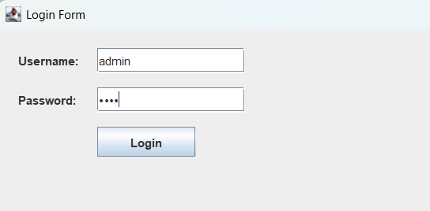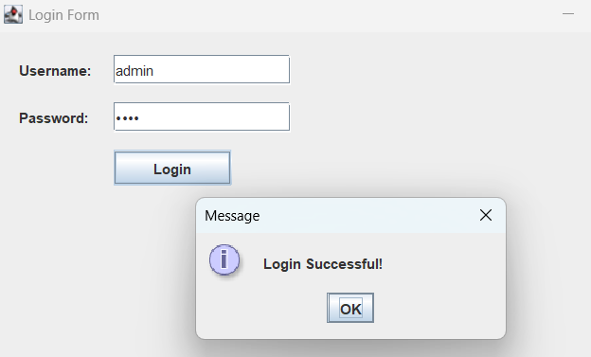

- CRUD Operations for a Student Management System
- Description: Develop a simple student management system with the following features:
  - Add new student details (name, roll number, course).
  - View the list of students in a JTable.
  - Update student details.
  - Delete student records.
StudentCURD.java
package swing;
import javax.swing.*;
import javax.swing.table.DefaultTableModel;
import java.awt.event.*;
import java.sql.*;
public class StudentCURD {
public static void main(String[] args) {
JFrame frame = new JFrame("Student System");
frame.setSize(600, 400);
frame.setLayout(null);
JLabel l1 = new JLabel("Name");
l1.setBounds(20, 20, 80, 25);
frame.add(l1);
JLabel l2 = new JLabel("Roll");
l2.setBounds(200, 20, 80, 25);
frame.add(l2);
JLabel l3 = new JLabel("Course");
l3.setBounds(380, 20, 80, 25);
frame.add(l3);
// TextFields
JTextField name = new JTextField();
name.setBounds(20, 50, 150, 25);
frame.add(name);
JTextField roll = new JTextField();
roll.setBounds(200, 50, 150, 25);
frame.add(roll);
JTextField course = new JTextField();
course.setBounds(380, 50, 150, 25);
frame.add(course);
JButton addBtn = new JButton("Add");
addBtn.setBounds(250, 90, 100, 30);
frame.add(addBtn);
// Table
DefaultTableModel model = new DefaultTableModel();
JTable table = new JTable(model);

model.addColumn("Name");
model.addColumn("Roll");
model.addColumn("Course");
JScrollPane sp = new JScrollPane(table);
sp.setBounds(20, 140, 540, 200);
frame.add(sp);
// Button Action
addBtn.addActionListener(new ActionListener() {
public void actionPerformed(ActionEvent e) {
String n = name.getText();
String r = roll.getText();
String c = course.getText();
try {
Connection con = DriverManager.getConnection(
"jdbc:mysql://localhost:3306/test", "root", "admin");
PreparedStatement ps = con.prepareStatement(
"INSERT INTO student VALUES (?, ?, ?)");
ps.setString(1, n);
ps.setString(2, r);
ps.setString(3, c);
ps.executeUpdate();
// Show in table
model.addRow(new Object[]{n, r, c});
JOptionPane.showMessageDialog(frame, "Student Added!");
} catch (Exception ex) {
ex.printStackTrace();
}
}
});
frame.setVisible(true);
}
}

DbConnection
create database test;
use test;
CREATE TABLE student (
name VARCHAR(50),
roll VARCHAR(20),
course VARCHAR(50)
);
select * from student;

- Library Book Inventory System
- Description: Create a library book inventory system that allows the following functionalities:
  - Add a new book with details like title, author, ISBN, and quantity.
  - View available books in the library using a JTable.
  - Update the book information (e.g., change the quantity of books).
  - Delete a book from the inventory.
  - Search for books by title or author.
LibraryBook.java
package swing;
import javax.swing.*;
import javax.swing.table.DefaultTableModel;
import java.awt.event.*;
import java.sql.*;
public class LibraryBook {
static DefaultTableModel model;
static JTable table;
public static void main(String[] args) {
JFrame frame = new JFrame("Library Inventory");
frame.setSize(800, 500);
frame.setLayout(null);
// Labels
JLabel l1 = new JLabel("Title");
l1.setBounds(20, 20, 80, 25);
frame.add(l1);
JLabel l2 = new JLabel("Author");
l2.setBounds(150, 20, 80, 25);
frame.add(l2);

JLabel l3 = new JLabel("ISBN");
l3.setBounds(280, 20, 80, 25);
frame.add(l3);
JLabel l4 = new JLabel("Qty");
l4.setBounds(410, 20, 80, 25);
frame.add(l4);
// TextFields
JTextField title = new JTextField();
title.setBounds(20, 50, 120, 25);
frame.add(title);
JTextField author = new JTextField();
author.setBounds(150, 50, 120, 25);
frame.add(author);
JTextField isbn = new JTextField();
isbn.setBounds(280, 50, 120, 25);
frame.add(isbn);
JTextField qty = new JTextField();
qty.setBounds(410, 50, 80, 25);
frame.add(qty);
JTextField search = new JTextField();
search.setBounds(520, 50, 150, 25);
frame.add(search);
// Buttons
JButton addBtn = new JButton("Add");
addBtn.setBounds(20, 90, 80, 30);
frame.add(addBtn);
JButton updateBtn = new JButton("Update");
updateBtn.setBounds(110, 90, 90, 30);
frame.add(updateBtn);
JButton deleteBtn = new JButton("Delete");
deleteBtn.setBounds(210, 90, 90, 30);
frame.add(deleteBtn);
JButton searchBtn = new JButton("Search");
searchBtn.setBounds(520, 90, 100, 30);
frame.add(searchBtn);
// Table
model = new DefaultTableModel();
table = new JTable(model);
model.addColumn("Title");
model.addColumn("Author");
model.addColumn("ISBN");
model.addColumn("Quantity");

JScrollPane sp = new JScrollPane(table);
sp.setBounds(20, 140, 740, 300);
frame.add(sp);
// Load data
loadData();
// ADD
addBtn.addActionListener(e -> {
try {
Connection con = getConnection();
PreparedStatement ps = con.prepareStatement(
"INSERT INTO books VALUES (?, ?, ?, ?)");
ps.setString(1, title.getText());
ps.setString(2, author.getText());
ps.setString(3, isbn.getText());
ps.setInt(4, Integer.parseInt(qty.getText()));
ps.executeUpdate();
loadData();
JOptionPane.showMessageDialog(frame, "Book Added!");
} catch (Exception ex) {
ex.printStackTrace();
}
});
// UPDATE
updateBtn.addActionListener(e -> {
try {
Connection con = getConnection();
PreparedStatement ps = con.prepareStatement(
"UPDATE books SET title=?, author=?, quantity=? WHERE isbn=?");
ps.setString(1, title.getText());
ps.setString(2, author.getText());
ps.setInt(3, Integer.parseInt(qty.getText()));
ps.setString(4, isbn.getText());
ps.executeUpdate();
loadData();
JOptionPane.showMessageDialog(frame, "Updated!");
} catch (Exception ex) {
ex.printStackTrace();
}
});
// DELETE
deleteBtn.addActionListener(e -> {
try {
Connection con = getConnection();

PreparedStatement ps = con.prepareStatement(
"DELETE FROM books WHERE isbn=?");
ps.setString(1, isbn.getText());
ps.executeUpdate();
loadData();
JOptionPane.showMessageDialog(frame, "Deleted!");
} catch (Exception ex) {
ex.printStackTrace();
}
});
// SEARCH
searchBtn.addActionListener(e -> {
try {
Connection con = getConnection();
PreparedStatement ps = con.prepareStatement(
"SELECT * FROM books WHERE title LIKE ? OR author LIKE ?");
ps.setString(1, "%" + search.getText() + "%");
ps.setString(2, "%" + search.getText() + "%");
ResultSet rs = ps.executeQuery();
model.setRowCount(0);
while (rs.next()) {
model.addRow(new Object[]{
rs.getString(1),
rs.getString(2),
rs.getString(3),
rs.getInt(4)
});
}
} catch (Exception ex) {
ex.printStackTrace();
}
});
frame.setVisible(true);
}
// DATABASE CONNECTION
public static Connection getConnection() throws Exception {
return DriverManager.getConnection(
"jdbc:mysql://localhost:3306/test", "root", "admin");
}
// LOAD TABLE DATA
public static void loadData() {
try {
Connection con = getConnection();
Statement st = con.createStatement();
ResultSet rs = st.executeQuery("SELECT * FROM books");
model.setRowCount(0);
while (rs.next()) {
model.addRow(new Object[]{
rs.getString(1),
rs.getString(2),
rs.getString(3),
rs.getInt(4)
});
}
} catch (Exception ex) {
ex.printStackTrace();
}
}
}
DbConnection
CREATE TABLE books (
title VARCHAR(100),
author VARCHAR(100),
isbn VARCHAR(50) PRIMARY KEY,
quantity INT
);
select * from books;
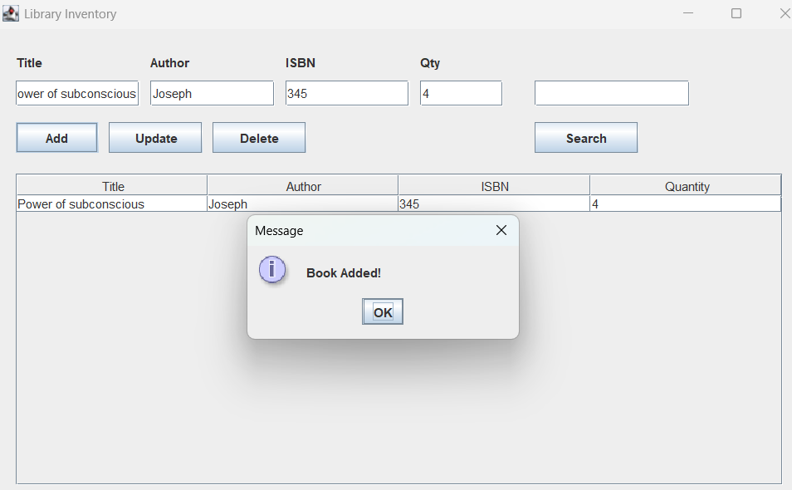
- Employee Management System
- Description: Build an employee management system with the following features:
  - Add a new employee to the database (employee ID, name, department, salary).
  - Display all employees in a JTable.
  - Update employee details (e.g., salary increase, department change).
  - Delete an employee record.
  - Calculate the total salary of all employees and display it in a label.
EmployeeManagement.java
package swing;
import javax.swing.*;
import javax.swing.table.DefaultTableModel;
import java.awt.event.*;
import java.sql.*;
public class EmployeeManagement {
static DefaultTableModel model;
static JLabel totalLabel;
public static void main(String[] args) {
JFrame frame = new JFrame("Employee System");
frame.setSize(800, 500);
frame.setLayout(null);
// Labels
JLabel l1 = new JLabel("ID");
l1.setBounds(20, 20, 80, 25);
frame.add(l1);
JLabel l2 = new JLabel("Name");
l2.setBounds(120, 20, 80, 25);
frame.add(l2);
JLabel l3 = new JLabel("Department");
l3.setBounds(250, 20, 100, 25);
frame.add(l3);
JLabel l4 = new JLabel("Salary");
l4.setBounds(400, 20, 80, 25);
frame.add(l4);
// TextFields
JTextField id = new JTextField();
id.setBounds(20, 50, 80, 25);
frame.add(id);
JTextField name = new JTextField();
name.setBounds(120, 50, 100, 25);
frame.add(name);

JTextField dept = new JTextField();
dept.setBounds(250, 50, 120, 25);
frame.add(dept);

JTextField salary = new JTextField();
salary.setBounds(400, 50, 100, 25);
frame.add(salary);

// Buttons
JButton addBtn = new JButton("Add");
addBtn.setBounds(20, 90, 80, 30);
frame.add(addBtn);

JButton updateBtn = new JButton("Update");
updateBtn.setBounds(110, 90, 90, 30);
frame.add(updateBtn);

JButton deleteBtn = new JButton("Delete");
deleteBtn.setBounds(210, 90, 90, 30);
frame.add(deleteBtn);

JButton totalBtn = new JButton("Total Salary");
totalBtn.setBounds(310, 90, 130, 30);
frame.add(totalBtn);

// Table
model = new DefaultTableModel();
JTable table = new JTable(model);

model.addColumn("ID");
model.addColumn("Name");
model.addColumn("Department");
model.addColumn("Salary");

JScrollPane sp = new JScrollPane(table);
sp.setBounds(20, 140, 740, 250);
frame.add(sp);

// Total Label
totalLabel = new JLabel("Total Salary: 0");
totalLabel.setBounds(20, 410, 300, 25);
frame.add(totalLabel);

loadData();

// ADD
addBtn.addActionListener(e -> {
try {
Connection con = getConnection();

int sal = Integer.parseInt(salary.getText());

PreparedStatement ps = con.prepareStatement(
"INSERT INTO employee VALUES (?, ?, ?, ?)");

ps.setString(1, id.getText());
ps.setString(2, name.getText());
ps.setString(3, dept.getText());
ps.setInt(4, sal);

ps.executeUpdate();

loadData();
JOptionPane.showMessageDialog(frame, "Employee Added!");
} catch (Exception ex) {
JOptionPane.showMessageDialog(frame, "Check Salary or ID!");
}
});
// UPDATE
updateBtn.addActionListener(e -> {
try {
Connection con = getConnection();
int sal = Integer.parseInt(salary.getText());
PreparedStatement ps = con.prepareStatement(
"UPDATE employee SET name=?, department=?, salary=? WHERE id=?");
ps.setString(1, name.getText());
ps.setString(2, dept.getText());
ps.setInt(3, sal);
ps.setString(4, id.getText());
ps.executeUpdate();
loadData();
JOptionPane.showMessageDialog(frame, "Updated!");
} catch (Exception ex) {
ex.printStackTrace();
}
});
// DELETE
deleteBtn.addActionListener(e -> {
try {
Connection con = getConnection();
PreparedStatement ps = con.prepareStatement(
"DELETE FROM employee WHERE id=?");

ps.setString(1, id.getText());
ps.executeUpdate();
loadData();
JOptionPane.showMessageDialog(frame, "Deleted!");
} catch (Exception ex) {
ex.printStackTrace();
}
});
// TOTAL SALARY
totalBtn.addActionListener(e -> {
try {
Connection con = getConnection();
Statement st = con.createStatement();
ResultSet rs = st.executeQuery("SELECT SUM(salary) FROM employee");
if (rs.next()) {
int total = rs.getInt(1);
totalLabel.setText("Total Salary: " + total);
}
} catch (Exception ex) {
ex.printStackTrace();
}
});

frame.setVisible(true);
}

// DB CONNECTION
public static Connection getConnection() throws Exception {
return DriverManager.getConnection(
"jdbc:mysql://localhost:3306/test", "root", "admin");
}
// LOAD DATA
public static void loadData() {
try {
Connection con = getConnection();
Statement st = con.createStatement();
ResultSet rs = st.executeQuery("SELECT * FROM employee");
model.setRowCount(0);
while (rs.next()) {
model.addRow(new Object[]{
rs.getString(1),
rs.getString(2),
rs.getString(3),
rs.getInt(4)
});
}
} catch (Exception ex) {
ex.printStackTrace();
}
}
}

DbConnection
CREATE TABLE employee (
id VARCHAR(20) PRIMARY KEY,
name VARCHAR(100),
department VARCHAR(100),
salary INT
);
select * from employee;
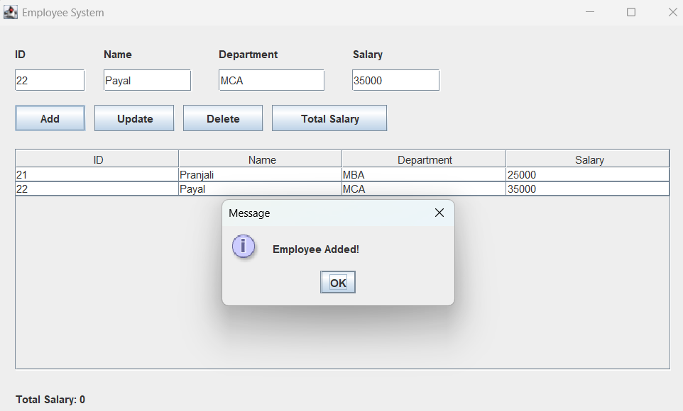
- Invoice Generation System
- Create an invoice generation system for a shop where customers can place orders. The system should:
  - Allow the user to add multiple items (product name, price, quantity).
  - Calculate the total cost of the items (price * quantity).
  - Generate and save the invoice to the database.
  - Display a list of previous invoices in a JTable with options to view individual invoices.

Invoice_gen.java

package swing;
import javax.swing.*;
import javax.swing.table.DefaultTableModel;
import java.awt.event.*;
import java.sql.*;
public class Invoice_gen {
static DefaultTableModel model;
static JLabel totalLabel;
static int total = 0;
public static void main(String[] args) {
JFrame frame = new JFrame("Invoice System");
frame.setSize(800, 500);
frame.setLayout(null);

// Labels
JLabel l1 = new JLabel("Product");
l1.setBounds(20, 20, 100, 25);
frame.add(l1);

JLabel l2 = new JLabel("Price");
l2.setBounds(200, 20, 100, 25);
frame.add(l2);

JLabel l3 = new JLabel("Qty");
l3.setBounds(350, 20, 100, 25);
frame.add(l3);

// Fields
JTextField product = new JTextField();
product.setBounds(20, 50, 150, 25);
frame.add(product);

JTextField price = new JTextField();
price.setBounds(200, 50, 100, 25);
frame.add(price);

JTextField qty = new JTextField();
qty.setBounds(350, 50, 100, 25);
frame.add(qty);

// Buttons
JButton addBtn = new JButton("Add Item");
addBtn.setBounds(20, 90, 120, 30);
frame.add(addBtn);

JButton saveBtn = new JButton("Save Invoice");
saveBtn.setBounds(150, 90, 150, 30);
frame.add(saveBtn);

JButton viewBtn = new JButton("View Invoices");
viewBtn.setBounds(320, 90, 150, 30);
frame.add(viewBtn);

// Table
model = new DefaultTableModel();
JTable table = new JTable(model);

model.addColumn("Product");
model.addColumn("Price");
model.addColumn("Qty");
model.addColumn("Total");

JScrollPane sp = new JScrollPane(table);
sp.setBounds(20, 140, 740, 250);
frame.add(sp);
// Total label
totalLabel = new JLabel("Total: 0");
totalLabel.setBounds(20, 410, 200, 25);
frame.add(totalLabel);
// ADD ITEM
addBtn.addActionListener(e -> {
try {
String p = product.getText();
int pr = Integer.parseInt(price.getText());
int q = Integer.parseInt(qty.getText());
int rowTotal = pr * q;
total += rowTotal;
model.addRow(new Object[]{p, pr, q, rowTotal});
totalLabel.setText("Total: " + total);
} catch (Exception ex) {
JOptionPane.showMessageDialog(frame, "Enter valid numbers!");
}
});
// SAVE INVOICE
saveBtn.addActionListener(e -> {
try {
Connection con = getConnection();
PreparedStatement ps = con.prepareStatement(
"INSERT INTO invoice(total) VALUES (?)",
Statement.RETURN_GENERATED_KEYS);
ps.setInt(1, total);
ps.executeUpdate();
ResultSet rs = ps.getGeneratedKeys();
int invoiceId = 0;
if (rs.next()) {
invoiceId = rs.getInt(1);
}
// save items
for (int i = 0; i < model.getRowCount(); i++) {
PreparedStatement ps2 = con.prepareStatement(
"INSERT INTO invoice_items VALUES (?, ?, ?, ?, ?)");
ps2.setInt(1, invoiceId);
ps2.setString(2, model.getValueAt(i, 0).toString());
ps2.setInt(3, (int) model.getValueAt(i, 1));
ps2.setInt(4, (int) model.getValueAt(i, 2));
ps2.setInt(5, (int) model.getValueAt(i, 3));
ps2.executeUpdate();
}
JOptionPane.showMessageDialog(frame, "Invoice Saved!");
} catch (Exception ex) {
ex.printStackTrace();
}
});
// VIEW INVOICES
viewBtn.addActionListener(e -> {
try {
Connection con = getConnection();
Statement st = con.createStatement();
ResultSet rs = st.executeQuery("SELECT * FROM invoice");
model.setRowCount(0);
while (rs.next()) {
model.addRow(new Object[]{
"Invoice ID: " + rs.getInt(1),
"",
"",
rs.getInt(2)
});
}
} catch (Exception ex) {
ex.printStackTrace();
}
});
frame.setVisible(true);
}
public static Connection getConnection() throws Exception {
return DriverManager.getConnection(
"jdbc:mysql://localhost:3306/test", "root", "admin");
}
}

DbConnection
CREATE TABLE invoice (
id INT AUTO_INCREMENT PRIMARY KEY,
total INT
);
select * from invoice;

CREATE TABLE invoice_items (
invoice_id INT,
product VARCHAR(100),
price INT,
qty INT,
total INT
);
select * from invoice_items;

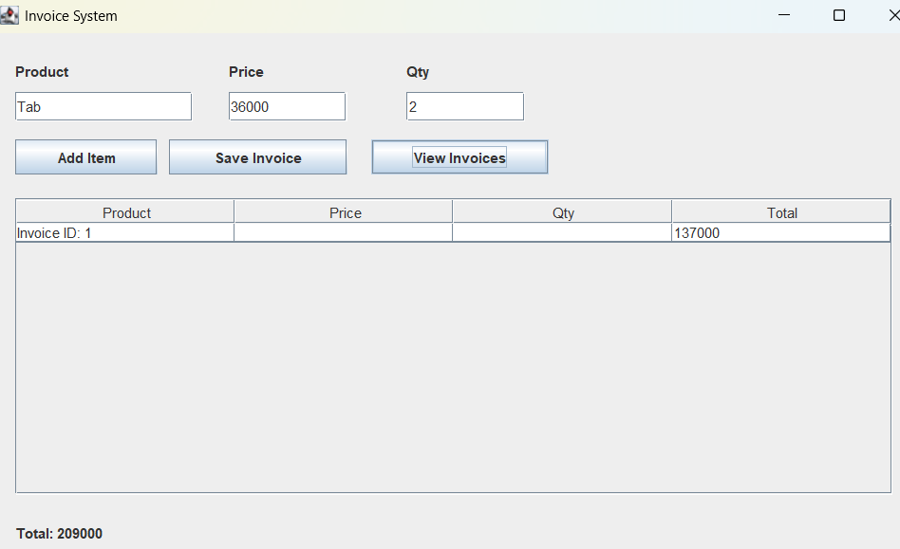
- Product Inventory System
- Create a product inventory tool with database support.
Fields: Product ID, Product Name, Quantity, Price, Category (using JComboBox)
T asks:
- Add products
- Update stock
- View current inventory in a JTable
- Delete products
Product_Inven.java
package swing;
import javax.swing.*;
import javax.swing.table.DefaultTableModel;
import java.awt.event.*;
import java.sql.*;

public class Product_Inven {

static DefaultTableModel model;

public static void main(String[] args) {

JFrame frame = new JFrame("Product Inventory");
frame.setSize(800, 500);
frame.setLayout(null);

// Labels
JLabel l1 = new JLabel("ID");
l1.setBounds(20, 20, 80, 25);
frame.add(l1);

JLabel l2 = new JLabel("Name");
l2.setBounds(120, 20, 80, 25);
frame.add(l2);

JLabel l3 = new JLabel("Qty");
l3.setBounds(250, 20, 80, 25);
frame.add(l3);

JLabel l4 = new JLabel("Price");
l4.setBounds(350, 20, 80, 25);
frame.add(l4);

JLabel l5 = new JLabel("Category");
l5.setBounds(480, 20, 80, 25);
frame.add(l5);

// Fields
JTextField id = new JTextField();
id.setBounds(20, 50, 80, 25);
frame.add(id);

JTextField name = new JTextField();
name.setBounds(120, 50, 100, 25);
frame.add(name);

JTextField qty = new JTextField();
qty.setBounds(250, 50, 80, 25);
frame.add(qty);

JTextField price = new JTextField();
price.setBounds(350, 50, 100, 25);
frame.add(price);

// ComboBox
String categories[] = {"Electronics", "Clothing", "Food", "Books"};
JComboBox<String> category = new JComboBox<>(categories);
category.setBounds(480, 50, 120, 25);
frame.add(category);

// Buttons
JButton addBtn = new JButton("Add");
addBtn.setBounds(20, 90, 80, 30);
frame.add(addBtn);

JButton updateBtn = new JButton("Update");
updateBtn.setBounds(110, 90, 90, 30);
frame.add(updateBtn);

JButton deleteBtn = new JButton("Delete");
deleteBtn.setBounds(210, 90, 90, 30);
frame.add(deleteBtn);

// Table
model = new DefaultTableModel();
JTable table = new JTable(model);

model.addColumn("ID");
model.addColumn("Name");
model.addColumn("Qty");
model.addColumn("Price");
model.addColumn("Category");

JScrollPane sp = new JScrollPane(table);
sp.setBounds(20, 140, 740, 300);
frame.add(sp);

loadData();

// ADD
addBtn.addActionListener(e -> {
try {
Connection con = getConnection();

PreparedStatement ps = con.prepareStatement(
"INSERT INTO product VALUES (?, ?, ?, ?, ?)");

ps.setString(1, id.getText());
ps.setString(2, name.getText());
ps.setInt(3, Integer.parseInt(qty.getText()));
ps.setInt(4, Integer.parseInt(price.getText()));
ps.setString(5, category.getSelectedItem().toString());

ps.executeUpdate();

loadData();
JOptionPane.showMessageDialog(frame, "Product Added!");

} catch (Exception ex) {
JOptionPane.showMessageDialog(frame, "Check inputs!");
}
});

// UPDATE
updateBtn.addActionListener(e -> {
try {
Connection con = getConnection();

PreparedStatement ps = con.prepareStatement(
"UPDATE product SET name=?, qty=?, price=?, category=? WHERE id=?");

ps.setString(1, name.getText());
ps.setInt(2, Integer.parseInt(qty.getText()));
ps.setInt(3, Integer.parseInt(price.getText()));
ps.setString(4, category.getSelectedItem().toString());
ps.setString(5, id.getText());

ps.executeUpdate();

loadData();
JOptionPane.showMessageDialog(frame, "Updated!");

} catch (Exception ex) {
ex.printStackTrace();
}
});

// DELETE
deleteBtn.addActionListener(e -> {
try {
Connection con = getConnection();

PreparedStatement ps = con.prepareStatement(
"DELETE FROM product WHERE id=?");

ps.setString(1, id.getText());
ps.executeUpdate();

loadData();
JOptionPane.showMessageDialog(frame, "Deleted!");

} catch (Exception ex) {
ex.printStackTrace();
}
});

frame.setVisible(true);
}

// DB CONNECTION
public static Connection getConnection() throws Exception {
return DriverManager.getConnection(
"jdbc:mysql://localhost:3306/test", "root", "admin");
}

// LOAD DATA
public static void loadData() {
try {
Connection con = getConnection();
Statement st = con.createStatement();
ResultSet rs = st.executeQuery("SELECT * FROM product");

model.setRowCount(0);

while (rs.next()) {
model.addRow(new Object[]{
rs.getString(1),
rs.getString(2),
rs.getInt(3),
rs.getInt(4),
rs.getString(5)
});
}

} catch (Exception ex) {
ex.printStackTrace();
}
}
}

DbConnection

CREATE TABLE product (
id VARCHAR(20) PRIMARY KEY,
name VARCHAR(100),
qty INT,
price INT,
category VARCHAR(50)
);
select * from product;

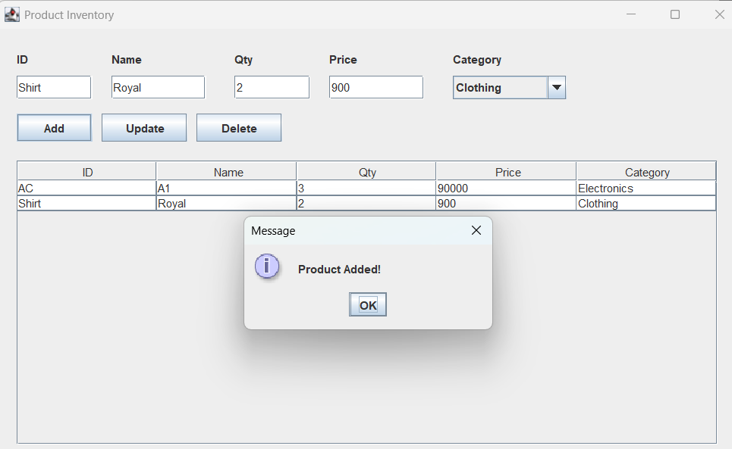

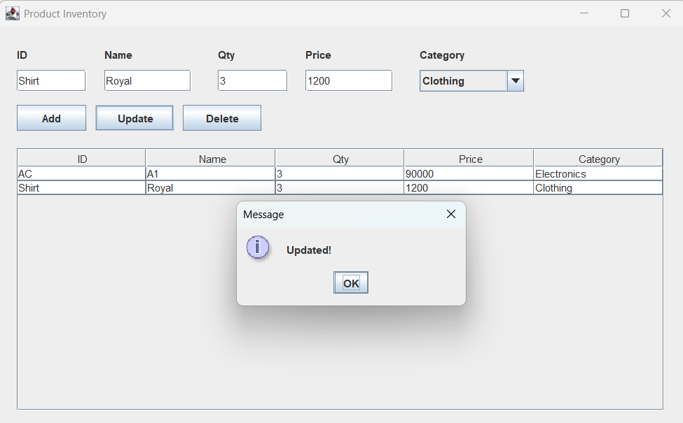

7. Basic Menu Bar Creation
- Objective: Create a basic window with a menu bar.
- Question:
Design a Java Swing application with a JMenuBar containing two menus: File and Edit. Under File, include New, Open, and Exit options. Under Edit, include Cut, Copy, and Paste. When each menu item is clicked, show a message dialog indicating the item clicked.
MenuExample.java
package swing;
import javax.swing.*;
import java.awt.event.*;
public class MenuExample {
public static void main(String[] args) {
JFrame frame = new JFrame("Menu Example");
frame.setSize(400, 300);
// Menu Bar
JMenuBar menuBar = new JMenuBar();

// File Menu
JMenu fileMenu = new JMenu("File");

JMenuItem newItem = new JMenuItem("New");
JMenuItem openItem = new JMenuItem("Open");
JMenuItem exitItem = new JMenuItem("Exit");

fileMenu.add(newItem);
fileMenu.add(openItem);
fileMenu.add(exitItem);

// Edit Menu
JMenu editMenu = new JMenu("Edit");

JMenuItem cutItem = new JMenuItem("Cut");
JMenuItem copyItem = new JMenuItem("Copy");
JMenuItem pasteItem = new JMenuItem("Paste");

editMenu.add(cutItem);
editMenu.add(copyItem);
editMenu.add(pasteItem);

// Add menus to bar
menuBar.add(fileMenu);
menuBar.add(editMenu);

frame.setJMenuBar(menuBar);

// Action Listeners
newItem.addActionListener(e ->
JOptionPane.showMessageDialog(frame, "New clicked"));
openItem.addActionListener(e ->
JOptionPane.showMessageDialog(frame, "Open clicked"));
exitItem.addActionListener(e -> {
JOptionPane.showMessageDialog(frame, "Exit clicked");
System.exit(0);
});
cutItem.addActionListener(e ->
JOptionPane.showMessageDialog(frame, "Cut clicked"));
copyItem.addActionListener(e ->
JOptionPane.showMessageDialog(frame, "Copy clicked"));
pasteItem.addActionListener(e ->
JOptionPane.showMessageDialog(frame, "Paste clicked"));
frame.setVisible(true);
}
}

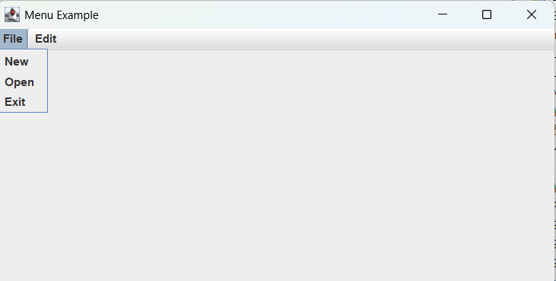
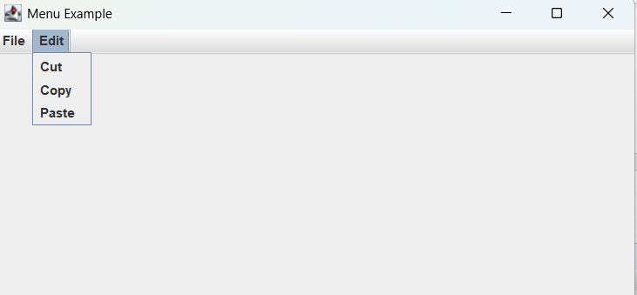

  - ComboBox with Database Values
Objective: Populate Swing components with data from DB.
Question: Create a form with a JComboBox for selecting a department. Populate the list from a departments table in the database using JDBC
ComboBoxDB.java
package swing;
import javax.swing.*;
import java.sql.*;

public class ComboBoxDB {

public static void main(String[] args) {

JFrame frame = new JFrame("Department Selection");
frame.setSize(400, 200);
frame.setLayout(null);

JLabel label = new JLabel("Select Department:");
label.setBounds(20, 30, 150, 25);
frame.add(label);

JComboBox<String> combo = new JComboBox<>();
combo.setBounds(180, 30, 150, 25);
frame.add(combo);

// Load data from DB
try {
Connection con = DriverManager.getConnection(
"jdbc:mysql://localhost:3306/test", "root", "admin");

Statement st = con.createStatement();
ResultSet rs = st.executeQuery("SELECT name FROM departments");

while (rs.next()) {
combo.addItem(rs.getString("name"));
}

} catch (Exception ex) {
ex.printStackTrace();
}

// Button to show selected
JButton btn = new JButton("Submit");
btn.setBounds(120, 80, 100, 30);
frame.add(btn);

btn.addActionListener(e -> {
String selected = combo.getSelectedItem().toString();
JOptionPane.showMessageDialog(frame, "Selected: " + selected);
});

frame.setVisible(true);
}
}
DbConnection
CREATE TABLE departments (
id INT AUTO_INCREMENT PRIMARY KEY,
name VARCHAR(100)
);
INSERT INTO departments (name) VALUES
('HR'),
('IT'),
('Finance'),
('Marketing');
select * from departments;
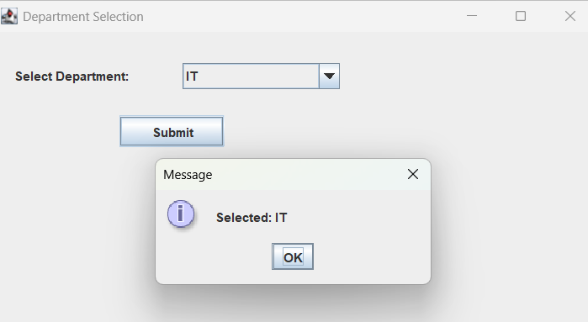
  - Attendance System
Objective: Combine multiple Swing and JDBC skills.
Question: Create a GUI to mark student attendance. Dropdown or text input for student ID,
date, and attendance status (Present/Absent). Use JDBC to insert and retrieve attendance
data from the database.

AttendanceSystem.java
package swing;
import javax.swing.*;
import javax.swing.table.DefaultTableModel;
import java.awt.event.*;
import java.sql.*;

public class AttendanceSystem {

static DefaultTableModel model;

public static void main(String[] args) {

JFrame frame = new JFrame("Attendance System");
frame.setSize(700, 450);
frame.setLayout(null);

// Labels
JLabel l1 = new JLabel("Student ID");
l1.setBounds(20, 20, 100, 25);
frame.add(l1);

JLabel l2 = new JLabel("Date (YYYY-MM-DD)");
l2.setBounds(180, 20, 150, 25);
frame.add(l2);

JLabel l3 = new JLabel("Status");
l3.setBounds(400, 20, 100, 25);
frame.add(l3);

// Fields
JTextField studentId = new JTextField();
studentId.setBounds(20, 50, 120, 25);
frame.add(studentId);

JTextField date = new JTextField();
date.setBounds(180, 50, 150, 25);
frame.add(date);

// ComboBox
String statusOptions[] = {"Present", "Absent"};
JComboBox<String> status = new JComboBox<>(statusOptions);
status.setBounds(400, 50, 120, 25);
frame.add(status);

// Buttons
JButton addBtn = new JButton("Mark Attendance");
addBtn.setBounds(20, 90, 160, 30);
frame.add(addBtn);

JButton viewBtn = new JButton("View Attendance");
viewBtn.setBounds(200, 90, 160, 30);
frame.add(viewBtn);

// Table
model = new DefaultTableModel();
JTable table = new JTable(model);

model.addColumn("Student ID");
model.addColumn("Date");
model.addColumn("Status");

JScrollPane sp = new JScrollPane(table);
sp.setBounds(20, 140, 640, 240);
frame.add(sp);

// ADD ATTENDANCE
addBtn.addActionListener(e -> {
try {
Connection con = getConnection();

PreparedStatement ps = con.prepareStatement(
"INSERT INTO attendance VALUES (?, ?, ?)");

ps.setString(1, studentId.getText());
ps.setString(2, date.getText());
ps.setString(3, status.getSelectedItem().toString());

ps.executeUpdate();

JOptionPane.showMessageDialog(frame, "Attendance Saved!");

} catch (Exception ex) {
JOptionPane.showMessageDialog(frame, "Error! Check data.");
}
});

// VIEW ATTENDANCE
viewBtn.addActionListener(e -> {
try {
Connection con = getConnection();
Statement st = con.createStatement();

ResultSet rs = st.executeQuery("SELECT * FROM attendance");

model.setRowCount(0);

while (rs.next()) {
model.addRow(new Object[]{
rs.getString(1),
rs.getString(2),
rs.getString(3)
});
}

} catch (Exception ex) {
ex.printStackTrace();
}
});

frame.setVisible(true);
}

// DB CONNECTION
public static Connection getConnection() throws Exception {
return DriverManager.getConnection(
"jdbc:mysql://localhost:3306/test", "root", "admin");
}
}
DbConnection
CREATE TABLE attendance (
student_id VARCHAR(50),
date DATE,
status VARCHAR(20)
);
select * from attendance;
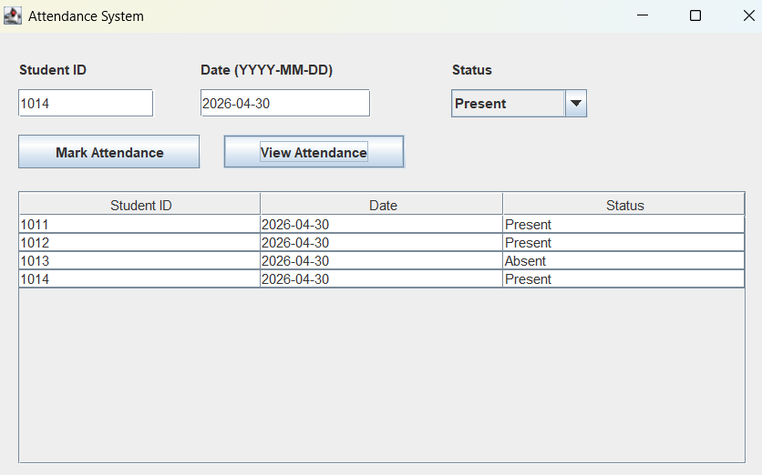

Servlet and JSP with JDBC
Question 1: Student Registration System
Objective: Create a web app to register students using JSP, Servlet, and JDBC.
Requirements:
- A JSP form to enter: Name, Email, Course, Roll No
- Servlet to handle form submission and save data in DB
- Show success or error message

StudentServlet.java

package server;

import java.io.*;
import javax.servlet.*;
import javax.servlet.http.*;
import javax.servlet.annotation.WebServlet;
import java.sql.*;

@WebServlet("/StudentServlet")
public class StudentServlet extends HttpServlet {

protected void doPost(HttpServletRequest req, HttpServletResponse res)
throws ServletException, IOException {
System.out.println("Servlet started");
String name = req.getParameter("name");
String email = req.getParameter("email");
String course = req.getParameter("course");
String rollno = req.getParameter("rollno");

try {
// 1. Load Driver
Class.forName("com.mysql.cj.jdbc.Driver");

// 2. Connect DB
Connection con = DriverManager.getConnection(
"jdbc:mysql://localhost:3306/login_db", "root", "admin");

// 3. Insert Query
PreparedStatement ps = con.prepareStatement(
"INSERT INTO students VALUES (?, ?, ?, ?)");

ps.setString(1, name);
ps.setString(2, email);
ps.setString(3, course);
ps.setString(4, rollno);

int i = ps.executeUpdate();
System.out.println("Rows inserted: " + i);

if(i > 0){
req.setAttribute("message", "Registration Successful!");
} else {
req.setAttribute("message", "Error! Try again.");
}
// Send back to same JSP
RequestDispatcher rd = req.getRequestDispatcher("register.jsp");
rd.forward(req, res);

con.close();

} catch (Exception e) {
System.out.println("Error occurred"); // ✅
e.printStackTrace();
}
}
}
Register.jsp
<!-- File: register.jsp -->
<html>
<head>
<title>Student Registration</title>
</head>
<body>

<h2>Student Registration Form</h2>

<form action="StudentServlet" method="post">

Name: <input type="text" name="name"><br><br>
Email: <input type="email" name="email"><br><br>
Course: <input type="text" name="course"><br><br>
Roll No: <input type="text" name="rollno"><br><br>

<input type="submit" value="Register">

</form>

<%
String msg = (String) request.getAttribute("message");
if(msg != null){
%>
<p style="color:green;"><%= msg %></p>
<%
}
%>

</body>
</html>

DbConnection
CREATE DATABASE login_db;
USE login_db;
CREATE TABLE students (
name VARCHAR(50),
email VARCHAR(50),
course VARCHAR(50),
rollno VARCHAR(20)
);
select * from students;
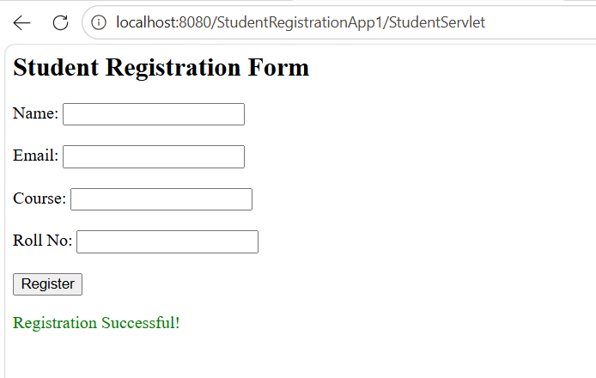

Question 2: Login System with JSP and Servlet
Objective: Implement a login module.
Requirements:
- JSP login form (username + password)
- Servlet to validate credentials
- Redirect to welcome.jsp on success, back to login on failure

LoginServlet.java
package server;

import java.io.*;
import javax.servlet.*;
import javax.servlet.http.*;
import javax.servlet.annotation.WebServlet;
import java.sql.*;

@WebServlet("/LoginServlet")
public class LoginServlet extends HttpServlet {

protected void doPost(HttpServletRequest req, HttpServletResponse res)
throws ServletException, IOException {

String username = req.getParameter("username");
String password = req.getParameter("password");

try {
// 1. Load Driver
Class.forName("com.mysql.cj.jdbc.Driver");

// 2. Create Connection
Connection con = DriverManager.getConnection(
"jdbc:mysql://localhost:3306/login_db", "root", "admin");

// 3. SQL Query
PreparedStatement ps = con.prepareStatement(
"SELECT * FROM users WHERE username=? AND password=?");

ps.setString(1, username);
ps.setString(2, password);

ResultSet rs = ps.executeQuery();

if(rs.next()) {
// Login success
res.setContentType("text/html");
PrintWriter out = res.getWriter();
out.println("<h2>Login Successful</h2>");
out.println("<h3>Welcome " + username + "</h3>");
} else {
// Login fail
req.setAttribute("message", "Invalid username or password");
RequestDispatcher rd = req.getRequestDispatcher("Login.jsp");
rd.forward(req, res);
}

con.close();

} catch (Exception e) {
e.printStackTrace();
}
}
}

Login.jsp

<!-- File: Login.jsp -->
<html>
<head>
<title>Login</title>
</head>
<body>

<h2>Login Page</h2>

<form action="LoginServlet" method="post">
Username: <input type="text" name="username"><br><br>
Password: <input type="password" name="password"><br><br>
<input type="submit" value="Login">
</form>

<%
String msg = (String) request.getAttribute("message");
if(msg != null){
%>
<p style="color:red;"><%= msg %></p>
<%
}
%>

</body>
</html>
DbConnection

CREATE DATABASE login_db;
USE login_db;
CREATE TABLE users (
username VARCHAR(50),
password VARCHAR(50)
);
INSERT INTO users VALUES ('admin', '1234');
select * from users;
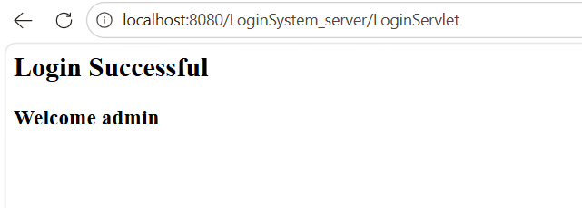
Question 3: Create a simple login form using JSP and Servlet.
  - JSP: Front-end form for username and password.
  - Servlet: Validate credentials (hardcoded or DB check), and redirect to a welcome page.

LoginServlet.java

package server;

import java.io.*;
import javax.servlet.*;
import javax.servlet.http.*;
import javax.servlet.annotation.WebServlet;

@WebServlet("/LoginServlet") // No web.xml needed
public class LoginServlet extends HttpServlet {

protected void doPost(HttpServletRequest req, HttpServletResponse res)
throws ServletException, IOException {

String username = req.getParameter("username");
String password = req.getParameter("password");

// Hardcoded check
if(username.equals("admin") && password.equals("1234")) {

// Redirect to welcome page (simple HTML output)
res.setContentType("text/html");
PrintWriter out = res.getWriter();

out.println("<html><body>");
out.println("<h2>Login Successful</h2>");
out.println("<h3>Welcome " + username + "</h3>");
out.println("</body></html>");

} else {
// Send back with error
req.setAttribute("message", "Invalid username or password");
RequestDispatcher rd = req.getRequestDispatcher("login.jsp");
rd.forward(req, res);
}
}
}
login.jsp
<html>
<head>
<title>Login</title>
</head>
<body>

<h2>Login Form</h2>

<form action="LoginServlet" method="post">
Username: <input type="text" name="username"><br><br>
Password: <input type="password" name="password"><br><br>
<input type="submit" value="Login">
</form>
<%
String msg = (String) request.getAttribute("message");
if(msg != null){
%>
<p style="color:red;"><%= msg %></p>
<%
}
%>
</body>
</html>
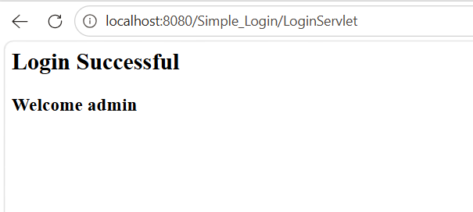

Question 5: Develop a JSP page to display user input.
  - Take name, email via a form.
  - On submission, show the data on another JSP page.

form.jsp
<html>
<head>
<title>User Form</title>
</head>
<body>

<h2>Enter Your Details</h2>

<form action="display.jsp" method="post">

Name: <input type="text" name="name"><br><br>

Email: <input type="email" name="email"><br><br>

<input type="submit" value="Submit">

</form>
</body>
</html>
display.jsp
<html>
<head>
<title>Display Data</title>
</head>
<body>

<h2>User Details</h2>

<%
String name = request.getParameter("name");
String email = request.getParameter("email");
%>

<p>Name: <%= name %></p>
<p>Email: <%= email %></p>

</body>
</html>

Question 6: Implement a simple registration system using JSP and Servlets.
  - JSP form: name, email, password, gender, etc.
  - Servlet: save the data (can be stored in-memory or in a simple database).
  - Display confirmation.

RegisterServlet.java

package server;

import java.io.*;
import javax.servlet.*;
import javax.servlet.http.*;
import javax.servlet.annotation.WebServlet;
import java.util.*;

@WebServlet("/RegisterServlet")
public class RegisterServlet extends HttpServlet {

// Store data in memory
static List<String> users = new ArrayList<>();

protected void doPost(HttpServletRequest req, HttpServletResponse res)
throws ServletException, IOException {

String name = req.getParameter("name");
String email = req.getParameter("email");
String password = req.getParameter("password");
String gender = req.getParameter("gender");

// Save data in list
String userData = "Name: " + name +
", Email: " + email +
", Gender: " + gender;

users.add(userData);

// Set success message
req.setAttribute("message", "Registration Successful!");

// Show same page again
RequestDispatcher rd = req.getRequestDispatcher("register.jsp");
rd.forward(req, res);
}
}
register.jsp
<html>
<head>
<title>Registration</title>
</head>
<body>

<h2>User Registration</h2>

<form action="RegisterServlet" method="post">

Name: <input type="text" name="name"><br><br>

Email: <input type="email" name="email"><br><br>

Password: <input type="password" name="password"><br><br>

Gender:
<input type="radio" name="gender" value="Male"> Male
<input type="radio" name="gender" value="Female"> Female
<br><br>

<input type="submit" value="Register">

</form>

<%
String msg = (String) request.getAttribute("message");
if(msg != null){
%>
<p style="color:green;"><%= msg %></p>
<%
}
%>

</body>
</html>

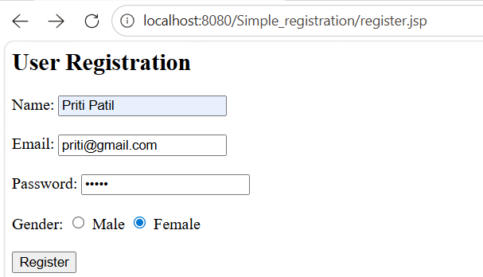
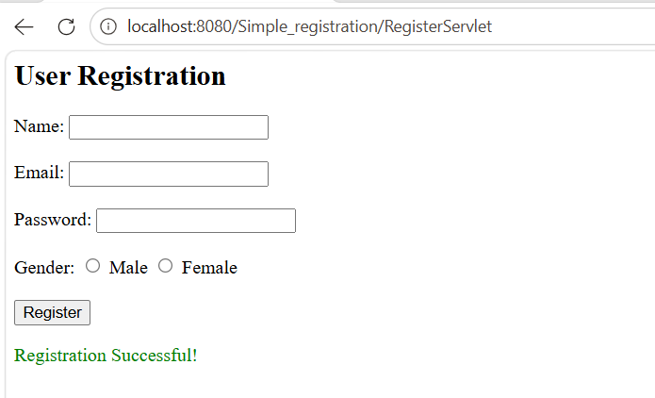
Question 7. Create a basic shopping cart system using JSP and Servlets.
  - Use JSP to display product list.
  - Servlet to manage cart (add/remove items).
  - Session tracking to maintain user’s cart.

CartServlet.java

package server;

import java.io.*;
import javax.servlet.*;
import javax.servlet.http.*;
import javax.servlet.annotation.WebServlet;
import java.util.*;

@WebServlet("/CartServlet")
public class CartServlet extends HttpServlet {

protected void doPost(HttpServletRequest req, HttpServletResponse res)
throws ServletException, IOException {

HttpSession session = req.getSession();

List<String> cart = (List<String>) session.getAttribute("cart");

if(cart == null){
cart = new ArrayList<>();
}

String[] products = req.getParameterValues("product");

if(products != null){
for(String p : products){
cart.add(p);
}
}

session.setAttribute("cart", cart);

res.sendRedirect("products.jsp");
}

protected void doGet(HttpServletRequest req, HttpServletResponse res)
throws ServletException, IOException {

HttpSession session = req.getSession();
List<String> cart = (List<String>) session.getAttribute("cart");

String action = req.getParameter("action");
String product = req.getParameter("product");

if("remove".equals(action) && cart != null){
cart.remove(product);
}

session.setAttribute("cart", cart);

res.sendRedirect("products.jsp");
}
}
products.jsp
<%@ page import="java.util.*" %>
<html>
<head>
<title>Shopping Cart</title>
</head>
<body>

<h2>Products</h2>

<form action="CartServlet" method="post">
<input type="hidden" name="action" value="add">

<input type="checkbox" name="product" value="Laptop"> Laptop<br>
<input type="checkbox" name="product" value="Mobile"> Mobile<br>
<input type="checkbox" name="product" value="Headphones"> Headphones<br><br>

<input type="submit" value="Add to Cart">
</form>

<hr>

<h2>Your Cart</h2>

<%
List<String> cart = (List<String>) session.getAttribute("cart");

if(cart != null && !cart.isEmpty()){
for(String item : cart){
%>
<p>
<%= item %>
<a href="CartServlet?action=remove&product=<%= item %>">Remove</a>
</p>
<%
}
} else {
%>
<p>Cart is empty</p>
<%
}
%>

</body>
</html>

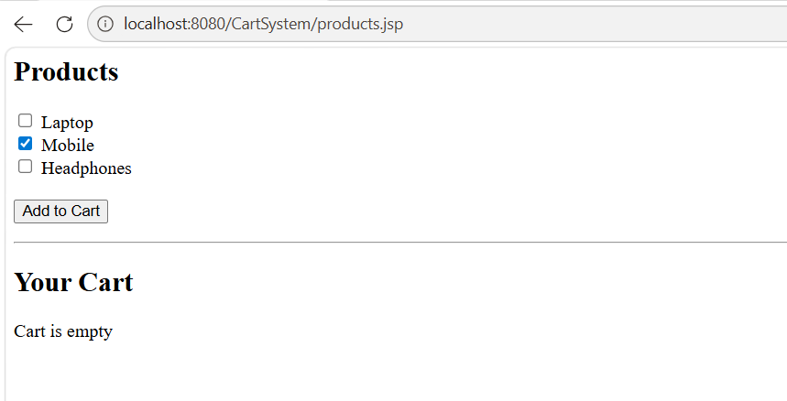
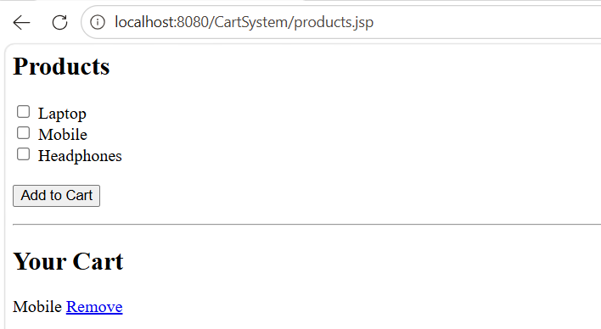
Question 8. Build a feedback system using JSP, Servlet, and JDBC.
  - Store feedback in a database.
  - JSP for form display and viewing feedback.
  - Servlet for data handling.

FeedbackServlet.java

package server;

import java.io.*;
import javax.servlet.*;
import javax.servlet.http.*;
import javax.servlet.annotation.WebServlet;
import java.sql.*;

@WebServlet("/FeedbackServlet")
public class FeedbackServlet extends HttpServlet {

protected void doPost(HttpServletRequest req, HttpServletResponse res)
throws ServletException, IOException {

String name = req.getParameter("name");
String message = req.getParameter("message");

try {
Class.forName("com.mysql.cj.jdbc.Driver");

Connection con = DriverManager.getConnection(
"jdbc:mysql://localhost:3306/login_db", "root", "admin");

PreparedStatement ps = con.prepareStatement(
"INSERT INTO feedback(name, message) VALUES (?, ?)");

ps.setString(1, name);
ps.setString(2, message);

ps.executeUpdate();

con.close();

} catch(Exception e){
e.printStackTrace();
}

// Redirect back to JSP to show updated feedback
res.sendRedirect("feedback.jsp");
}
}

feedback.jsp
<%@ page import="java.sql.*" %>
<html>
<head>
<title>Feedback System</title>
</head>
<body>

<h2>Give Feedback</h2>

<form action="FeedbackServlet" method="post">
Name: <input type="text" name="name"><br><br>
Message: <textarea name="message"></textarea><br><br>
<input type="submit" value="Submit">
</form>

<hr>

<h2>All Feedback</h2>

<%
try {
Class.forName("com.mysql.cj.jdbc.Driver");

Connection con = DriverManager.getConnection(
"jdbc:mysql://localhost:3306/login_db", "root", "admin");

Statement st = con.createStatement();
ResultSet rs = st.executeQuery("SELECT * FROM feedback");

while(rs.next()){
%>
<p>
<b><%= rs.getString("name") %>:</b>
<%= rs.getString("message") %>
</p>
<%
}

con.close();

} catch(Exception e){
out.println("Error loading feedback");
}
%>

</body>
</html>
DbConnection

CREATE TABLE feedback (
name VARCHAR(50),
message VARCHAR(200)
);
select * from feedback;

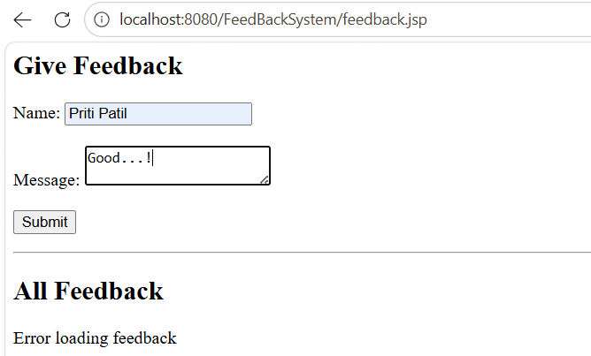
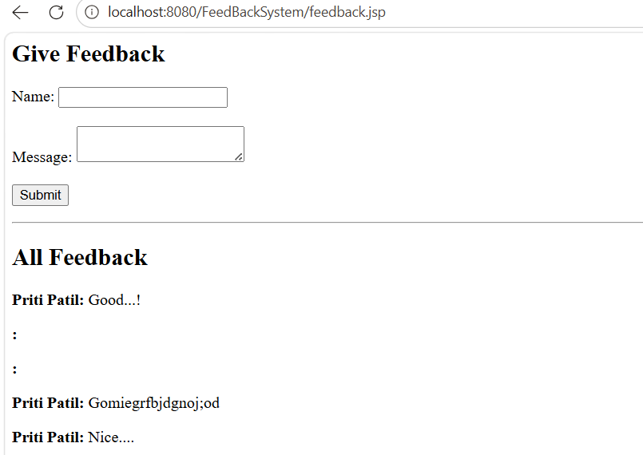
Question 9 : Mini Blog Application
  - Add/Edit/Delete blog posts using JSP/Servlet.
  - Store in DB.
  - Show list of blogs on home page.

BlogServlet.java

package server;

import java.io.*;
import javax.servlet.*;
import javax.servlet.http.*;
import javax.servlet.annotation.WebServlet;
import java.sql.*;

@WebServlet("/BlogServlet")
public class BlogServlet extends HttpServlet {

protected void doPost(HttpServletRequest req, HttpServletResponse res)
throws ServletException, IOException {

String action = req.getParameter("action");

if("add".equals(action)) {

String title = req.getParameter("title");
String content = req.getParameter("content");

try {
Class.forName("com.mysql.cj.jdbc.Driver");

Connection con = DriverManager.getConnection(
"jdbc:mysql://localhost:3306/login_db", "root", "admin");

PreparedStatement ps = con.prepareStatement(
"INSERT INTO posts(title, content) VALUES (?, ?)");

ps.setString(1, title);
ps.setString(2, content);

ps.executeUpdate();
con.close();

} catch(Exception e){
e.printStackTrace();
}
}

res.sendRedirect("blog.jsp");
}

protected void doGet(HttpServletRequest req, HttpServletResponse res)
throws ServletException, IOException {

String action = req.getParameter("action");

if("delete".equals(action)) {

String id = req.getParameter("id");

try {
Class.forName("com.mysql.cj.jdbc.Driver");

Connection con = DriverManager.getConnection(
"jdbc:mysql://localhost:3306/blog_db", "root", "admin");

PreparedStatement ps = con.prepareStatement(
"DELETE FROM posts WHERE id=?");

ps.setInt(1, Integer.parseInt(id));

ps.executeUpdate();
con.close();

} catch(Exception e){
e.printStackTrace();
}
}

res.sendRedirect("blog.jsp");
}
}

blog.jsp
<%@ page import="java.sql.*" %>
<html>
<head>
<title>Mini Blog</title>
</head>
<body>

<h2>Add Blog Post</h2>

<form action="BlogServlet" method="post">
<input type="hidden" name="action" value="add">

Title: <input type="text" name="title"><br><br>
Content: <textarea name="content"></textarea><br><br>

<input type="submit" value="Add Post">
</form>

<hr>

<h2>All Blog Posts</h2>

<%
try {
Class.forName("com.mysql.cj.jdbc.Driver");

Connection con = DriverManager.getConnection(
"jdbc:mysql://localhost:3306/blog_db", "root", "admin");

Statement st = con.createStatement();
ResultSet rs = st.executeQuery("SELECT * FROM posts");

while(rs.next()){
%>
<div style="border:1px solid black; padding:10px; margin:10px;">
<h3><%= rs.getString("title") %></h3>
<p><%= rs.getString("content") %></p>

<a href="BlogServlet?action=delete&id=<%= rs.getInt("id") %>">
Delete
</a>
</div>
<%
}
con.close();
} catch(Exception e){
out.println("Error loading posts");
}
%>

</body>
</html>

DbConnection
CREATE DATABASE blog_db;

USE blog_db;

CREATE TABLE posts (
id INT AUTO_INCREMENT PRIMARY KEY,
title VARCHAR(100),
content VARCHAR(500)
);
select * from posts;

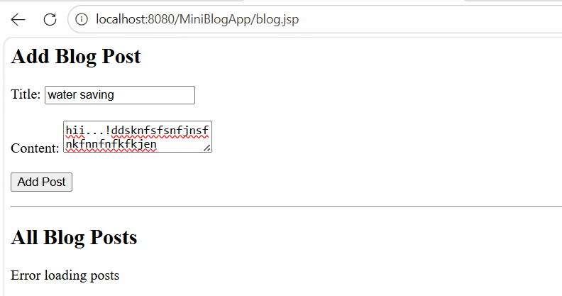
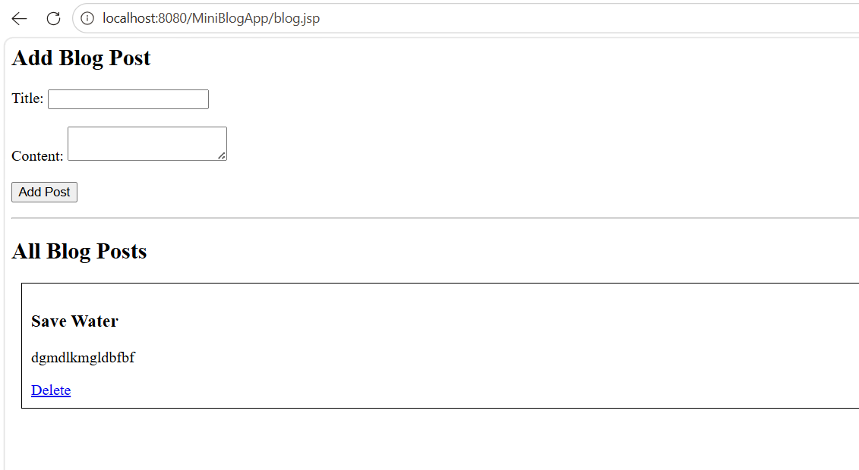
Question 10. Library Book Search System
- JSP form to enter search criteria.
- Servlet retrieves and displays matching books from DB.

SearchServlet.java

package server;

import java.io.*;
import javax.servlet.*;
import javax.servlet.http.*;
import javax.servlet.annotation.WebServlet;
import java.sql.*;

@WebServlet("/SearchServlet")
public class SearchServlet extends HttpServlet {

protected void doPost(HttpServletRequest req, HttpServletResponse res)
throws ServletException, IOException {

String title = req.getParameter("title");

try {
Class.forName("com.mysql.cj.jdbc.Driver");

Connection con = DriverManager.getConnection(
"jdbc:mysql://localhost:3306/library_db", "root", "admin");

PreparedStatement ps = con.prepareStatement(
"SELECT * FROM books WHERE title LIKE ?");

ps.setString(1, "%" + title + "%");

ResultSet rs = ps.executeQuery();

// send result to JSP
req.setAttribute("result", rs);

RequestDispatcher rd = req.getRequestDispatcher("search.jsp");
rd.forward(req, res);

} catch(Exception e){
e.printStackTrace();
}
}
}

search.jsp
<%@ page import="java.sql.*" %>
<html>
<head>
<title>Library Search</title>
</head>
<body>

<h2>Search Books</h2>

<form action="SearchServlet" method="post">
Enter Title: <input type="text" name="title">
<input type="submit" value="Search">
</form>

<hr>

<h2>Search Results</h2>

<%
ResultSet rs = (ResultSet) request.getAttribute("result");

if(rs != null){
while(rs.next()){
%>
<p>
<b><%= rs.getString("title") %></b>
by <%= rs.getString("author") %>
</p>
<%
}
}
%>

</body>
</html>

DbConnection
CREATE DATABASE library_db;

USE library_db;

CREATE TABLE books (
id INT AUTO_INCREMENT PRIMARY KEY,
title VARCHAR(100),
author VARCHAR(100)
);

INSERT INTO books(title, author) VALUES
('Java Basics', 'James Gosling'),
('Servlet Guide', 'John Doe'),
('JSP Tutorial', 'Jane Smith');
select * from books;
